## 202030-CRJ 245 YW1-Criminology (WE)

|  |  |
| --- | --- |
| Writing Assignment #1Stuart KetchamCrime: Lindbergh Baby Confidence TrickCriminal: Gaston Bullock Means | [Photo Citation: Library of Congress](https://loc.gov/pictures/resource/npcc.25463/) |

# Crime Details

Gaston Bullock Means had a long history of confidence schemes and even served time in jail by the time he stole over $100,000 with his final confidence trick.

In this case, the victim was not the Lindbergh family themselves, but rather an interested and wealthy third party, Evalyn Walsh McLean. She was a famous heiress and wife of Edward McLean, the owner and publisher of The Washington Post for 17 years. Evalyn McLean was the Hope Diamond owner for a period and is immortalized for her diplomacy work in the lyrics of the song “Anything Goes” (Cole Porter 1934). McLean appears to have involved herself in the Lindberg case from altruistic motives, or perhaps for additional notoriety.

Gaston Means was always looking for opportunities to swindle people out of money. He had already been trying to swindle money from “several rich men” (Hoover, 1936, pg. 84) regarding the Lindbergh kidnapping when Evalyn McLean sought him out. She believed him to have contacts in the underworld due to his reputation and a previous conviction and wanted his help in tracking down the kidnappers.

Based on his claims to be in contact with the kidnappers, McLean turned over $100,000 to Means to pay the ransom. Means proceeded to weave a long series of stories to keep McLean from knowing she had been tricked and possibly get additional money from her. Promises to deliver the baby ensued, along with a confederate posing as a kidnapper, and other deceptions all designed to confuse Mrs. McLean. Eventually, she did go to the police, which lead to Means’s trial and conviction.

# Theories

Gaston Means deceived countless people and even government agencies before his final conviction. For the most part, he was quite successful as a “con man.”

Behavior theory states that behaviors that yield rewards are likely to be repeated. This theory applies to Gaston Means’s confidence trick of Mrs. McLean as he had previously gotten away with many crimes, reaping the gains without paying the consequences. By that time, his dishonesty had garnered him enough money to support his family in a “mansion with three servants and a chauffeur-driven limousine.” (Yanchisin, 1991, paragraph 9)

Rational choice theory proposes that Gaston likely made a decision to commit the crime that was at least logical to him. Given all his previous successful crimes, he probably perceived the risk as relatively low compared to the potentially substantial financial gain.

# Theory 1 – Behavior Theory

“Behavior theory posits that individual behavior that is rewarded will increase in frequency and behavior that is punished will decrease in frequency.” (Schmalleger pg. 92.) A pattern of positive reinforcement of criminal activity through financial gain, and the absence of judicial punishment, is a theme throughout Gaston Means’s life.

Why would Gaston Means choose to try to trick someone into giving him over $100,000 (nearly $2 million in 2020)? As often happens with criminals, the crimes start small, and a pattern develops over time. In his youth, he stole money from his mother’s purse and derived satisfaction from seeing their maid fired for the crime. (Yanchisin, 1991, paragraph 2)

After a few years of attempting life working within the public school system, and as a salesman, he began work as a detective for the New York City detective agency of William J. Burns, formerly chief of the U.S. Secret Service. Here his life of dubious activities seems to start. Some of the activities he engaged in, both assigned and not assigned, range from the questionable to the criminal.

Other than the Lindbergh hoax, his most audacious crime was the defrauding and murder of Maude King, a wealthy widow. He worked his way into her confidence and gained control of her assets. After losing all her money in the stock market, Means took her on a hunting trip and returned with her dead body, reporting that she had shot herself. This, finally, did gain the attention of the authorities, and he was put on trial. Despite a convincing case against him, Gaston Means was found not guilty of murder and went free. Literally getting away with murder must have had an impact on his future behavior.

“Human behavior, according to the behavioral perspective, is thus a response to the environment… The presence or absence of a behavior in the future depends on the balance between rewards and punishments associated with it now…. The association between criminal activities and the rewards of excitement, thrill, money, praise, and group membership will increase the individual’s participation in these activities, despite the risks of punishment and social disapproval.” (Hoss, Moloney, & Chambliss, 2016, pg. 369)

The pattern of ongoing reward without punishment must have given Means a sense of invulnerability, lending his ongoing schemes a scale seldom seen in history, up until the Lindbergh baby hoax, where he finally received his comeuppance.

# Theory 2 – Rational Choice Theory

Rational choice theory is “a perspective holding that criminality is the result of conscious choice and predicts that individuals choose to commit crime when the benefits outweigh the costs of disobeying the law.” (Schmalleger pg. 41.) Based on his experience and knowledge of his victim, Gaston Means evaluated that his rewards outweighed the risks of committing the crime.

Confidence tricks fall somewhat between the cracks when categorizing crime. It is a sort of act that is partly robbery and partly white-collar crime. We should classify this specific crime as the latter due to the gentile manner in which it was handled.

When looking at white-collar crimes, rational-choice theory comes much more into play than it does for violent or impulsive crimes. Over time, Gaston Means must have regularly questioned the risk involved in the commission of his crimes but experiencing his repeated success must have given him the confidence to continue.

In the commission of the crime against Mrs. McLean, he concluded that the size of the reward outweighed the risk of prison. After all, she had approached him, not the other way around. Further, she had a national reputation to protect and would not want to appear to be a fool. Furthermore, he probably judged from experience that he was unlikely to be convicted or may never even face prosecution. “All too often prosecutors fail to charge individuals for white-collar crime” (Jaakson, Johannsen, Karin, Vadi, Ashyrov, Mari-Liis 2019, pg. 98)

Gary Becker, a proponent of the rational choice model, proposed a formula in 1968 that represents an evaluation of a potential criminal’s risk vs. reward from a crime.

EU = pU (Y– f) + (1 – p) U (Y)

* “p” represents the risk of being caught
* “U” is a complex variable including things like potential income from legal activities and education
* “Y” is the income from the offense
* “f” is the monetary equivalent of punishment

(above from Becker 1968)

The actual value of p is unknown to the criminal, so it actually represents the criminal’s perceived risk. Based on a lifetime of experience, Gaston Means’s confidence would lower the p factor to near zero for the McLean confidence trick. Factor out p and all that remains is the potential income, weighted against his education and potential legitimate earnings. Given his history, he must have seen the risk as very low compared to the reward.

After being given the $100,000 so easily, he probably believed that she was foolish enough to let him keep it if he spun a convincing enough web of lies. He spent the succeeding days and weeks believing that he could convince McLean that the money had gone to the kidnappers and that he was blameless.

Even before the Lindbergh baby’s body was found, everything fell apart for Means when Mrs. McLean went to the authorities, suspecting that she had been conned. He went to jail for larceny but never admitted his guilt, and to this day, the money has never been found.

# Conclusion

Even after he died in prison, Gaston Bullock Means has somehow managed to craft his own legacy, even if it is as a criminal. His recorded exploits are larger than life, bordering on the cartoonish. Researching him, it becomes difficult to determine how much is real and how much hyperbole.

Whatever his motives, and whatever his crimes, he remains a fascinating character and is one of the few criminals from American history to make a lasting impression based on the brilliance of his storytelling and trickery, rather than purely on brutal atrocities.

He was given, by his family, opportunities that should have leant him away from the need to seek a life of crime. Instead, small early delinquencies trained him that crime had plentiful rewards, leading to larger and more frequent crimes. He made what he considered a rational choice to pick this avenue as something that appealed to him and would provide him with a comfortable life. Both factors culminate in the Lindbergh baby confidence trick, which finally ended his career.

# References Scholarly

Hoss, A. Y., Moloney, C., & Chambliss, W. J. (2016, December 8). Criminology Connecting Theory, Research and Practice. Retrieved October 23, 2020, from <https://www.google.com/books/edition/Criminology/7CQlDwAAQBAJ?hl=en>

Jaakson, K., Johannsen, L., Pedersen, K., Vadi, M., Ashyrov, G., Reino, A., & Sööt, M. (2018). The role of costs, benefits, and moral judgments in private-to-private corruption. Crime, Law, and Social Change, 71(1), 83–106. <https://doi.org/10.1007/s10611-018-9790-y>

Becker, G. (1968). Crime and Punishment: An Economic Approach. The Journal of Political Economy, 76(2), 169–217. <https://doi.org/10.1086/259394>

## Media

Hoover, J. (1936, December 01). The Amazing Mr. Means, The American Magazine v122 n06 [1936-12]. Retrieved October 22, 2020, from <https://archive.org/details/TheAmericanMagazineV122N06193612>

Adams, J. H. (n.d.). Means to an End - This Day in History - Colorful Character Countdown. Retrieved October 22, 2020, from <https://ahgalmanack.com/means-to-an-end/>

Yanchisin, D. (1991). Means, Gaston Bullock. Retrieved October 23, 2020, from <https://www.ncpedia.org/biography/means-gaston-bullock>

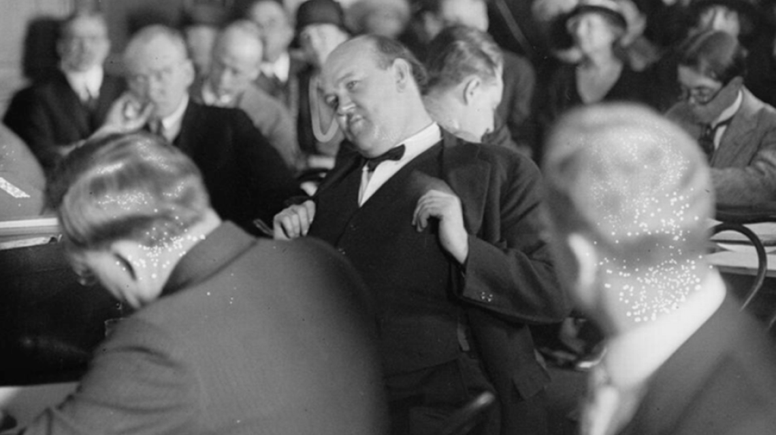

[Photo Citation: Library of Congress](https://www.loc.gov/pictures/resource/npcc.10740/)